PSCo TPL-001 Steady State CAP Guidance
- All CAPs should be saved to: S:\General-Offices-GO-01\ETDM\PSCO\2025_PSCO_TPL-001-5\Results\Steady_State\CAPs

- Please follow this naming convention:
  - [DESCRIPTIVE_FIX]_[MON_ELEMENT or CON]
  - Examples:
    - Proj_Add_Fiesta-Hopi_115kV.p
    - Proj_Add XIT_2nd_230-115_kV_Transformer.p
    - Proj_Upgrade_Line_Ratings_U04_Teague_to_Jal.p
    - LoadShed_P52-115-SPS-RIVERVIEW-V01.p
    - SysAdj_P22-Potash.p
    - SysAdj_Lubbock_South_Caps_Off.p

- Tips and tricks:
  - CAPs are not required for our neighboring system, so if the owner is non-PSCo, those should be labeled as follows:
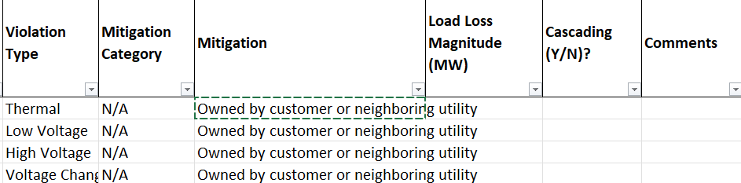

  - For non-BES cons or non-BES monitored facilities;
    - For a non-BES con that causes a violation on a BES facility (for e.g. a 69 KV line or a 69-115 kV t/f outage causing a 115kV line to overload) - CAPS are not required as per TPL criteria, however, we would still be identifying CAPs* for them in this year's TPL (treat them as low priority)- use 69 kV as the lower limit - for both N-1 and N-1-1 violations. Choose mitigation category as “Non-BES”.
    - For a BES con that causes a violation on a non-BES facility (for e.g. a 115 KV line outage causing a low voltage on a 69kV bus) - CAPS are not required as per TPL criteria, however, we would still be identifying CAPs* for them in this year's TPL (treat them as low priority)- use 69 kV as the lower limit- for just N-1 violations. Choose mitigation category as “Non-BES”.

    - For a non-BES con causing a violation on a non-BES facility (for e.g. a 69 KV line outage causing another 69kV line to overload)- CAPS are not required as per TPL criteria, but we would still be finding CAPs* for them in this year's TPL (treat these as lowest priority)- treat 69 kV as the lower limit- for just N-1 violations. Choose mitigation category as “Non-BES”.
    - *Using “CAP” here in the informal sense that we should have a project or other solution, not in the NERC-defined sense.

  - CAPs are not required for the following non-BES violations:
    - For a BES con that causes a violation on a non-BES facility for N-1-1 analysis.
    - For a non-BES con causing a violation on a non-BES facility for N-1-1 analysis.
    - Those should be labeled as follows:
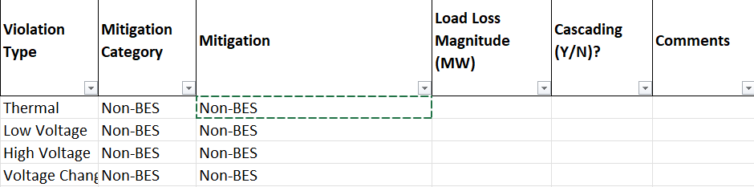

  - CAPs are not required for violations that only appear in a single sensitivity case. If a violation shows up for two sensitivity cases or just in one base case, it needs a CAP. Single sensitivity violations should be labeled as follows
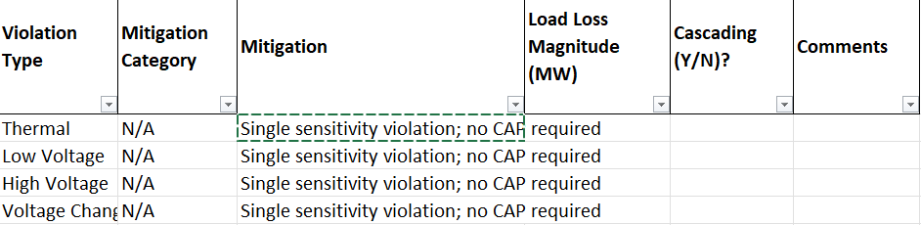
  - CAPs are not required for high voltages between 1.05 and 1.1 pu with delta_V less than the specified criteria. We are deciding whether to adjust the high voltage limits to 1.05 post-contingent, so planning asked us to flag on 1.05 pu for informational purposes. Once you have verified that delta_V is within criteria, label as follows
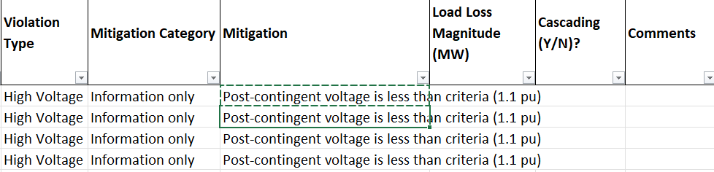

- CAPs are not required for post-contingent thermal loadings below 100%. For PSCo owned lines, use the following label if the thermal loading is below 100% post contingent:
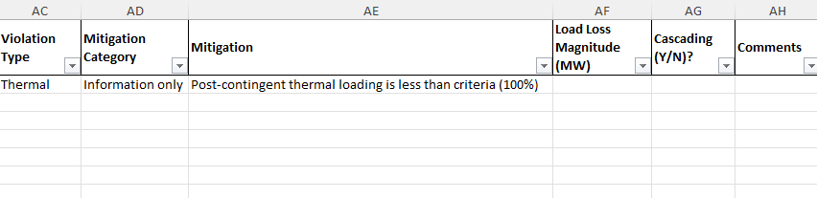
- We can use the emergency ratings for P2-P7 for underground lines and transformer, except that P2-1 use normal ratings
- For P6 events, per the standard, Load shed is allowed in the near term when a CAP cannot be constructed in the near-term time frame (1-5 years), CAPS are required long term 5+years. See Table 1 from the standard and the discussion is detailed in Requirement 2 .7 (Section 2.7.3).
- CAPs are not required for Delta V of more than 8% for P2-P7 events. CAPs are only required for P1 events that exceed this criteria.
- Extreme Events and cascading: Possible mitigations need only be populated for extreme events that produce cascading. All others can be documented as N/A with the comment that no cascading was identified. This guidance applies to both steady state and stability.
  - Justification:
    - R2.7 states: "For planning events shown in Table 1, when the analysis indicates an inability of the System to meet the performance requirements in Table 1, the Planning Assessment shall include Corrective Action Plan(s) addressing how the performance requirements will be met" [underline added]. This requirement does not say anything about extreme events
    - R3.2 states: "Studies shall be performed to assess the impact of the extreme events which are identified by the list created in R3, Part 3.5. If the analysis concludes there is Cascading caused by the occurrence of extreme events, evaluation of possible actions designed to reduce the likelihood or mitigate the consequences and adverse impacts of the events(s) shall be conducted." [emphasis added]
  - The dynamic equivalent to R3.2 is R4.2
- Cascading Events
  - For possible cascading mitigation is to look at the overloaded element or elements in the first iteration and see if there is a project or projects already identified to address the overloads. The cascading results will show the thermal overloads for the first iteration which the program shows as "Step 0"
  - For the cascading... Possible mitigations need only be populated for extreme events that produce cascading. All others can be documented as N/A with the comment that no cascading was identified. This guidance applies to both steady state and stability.
  - Justification:
    - R2.7 states: "For planning events shown in Table 1, when the analysis indicates an inability of the System to meet the performance requirements in Table 1, the Planning Assessment shall include Corrective Action Plan(s) addressing how the performance requirements will be met" [underline added]. This requirement does not say anything about extreme events
    - R3.2 states: "Studies shall be performed to assess the impact of the extreme events which are identified by the list created in R3, Part 3.5. If the analysis concludes there is Cascading caused by the occurrence of extreme events, evaluation of possible actions designed to reduce the likelihood or mitigate the consequences and adverse impacts of the events(s) shall be conducted." [emphasis added]
    - The dynamic equivalent to R3.2 is R4.2

